PUBPOL 4390/5390 “Day 17 in-class exercise”
Group Names (all members): _________Thelonious Goerz
____________________________________

We will use the datasets “G” for training (not Gsmall!), and “H” for testing. Each one is a unique set of births from 2015.

- Combine Datasets G and H. Create a binary LHS “LBW” = 1 if birthweight < 2500 grams

- Using Dataset G, estimate a Probit model, then obtain predicted probabilities after this. Then create “predicted classification” (a 0/1 variable).

- In the testing dataset (H), create a confusion matrix.

- In the testing dataset, calculate the following:

  - Accuracy = .95
  - TPR = .81
  - FPR = 0.03

- Create an ROC curve, and calculate the AUC = .94
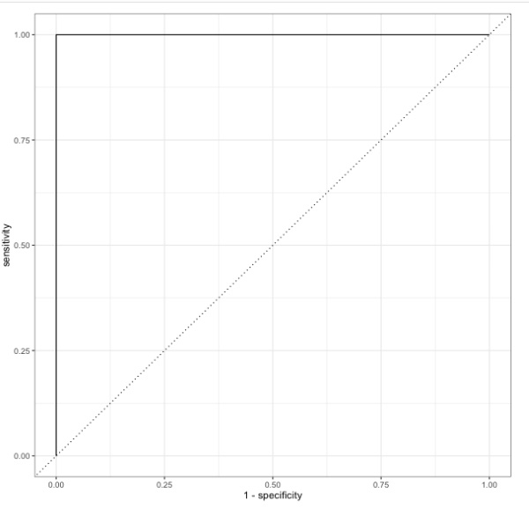
- In the testing data, produce a calibration plot
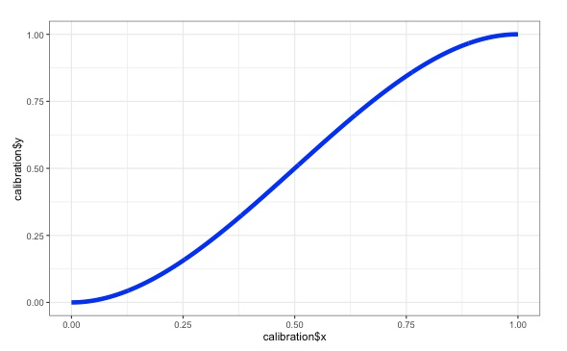

We will discuss together in class. Each group member should also upload a copy of their work to the class Canvas page under assignments. It’s OK for the group assignments to be identical among group members. Please make sure all group member names are on each person’s assignment.

